**CSE-3024 Web Mining**

**Lab Assignment 5**

**Alokam Nikhitha**

**19BCE2555**

Question

**Experiment 5**

Write a python program to perform the following encoding and decoding for the EVEN numbers between 1-20

1. Unary
2. Elias Gamma
3. Elias Delta
4. Golomb (b=10)

**Problem statement:**

To perform the following encoding and decoding for the EVEN numbers between 1-20

**Procedure:**

* Firstly, we will import the necessary numpy library to use mathematical functions like logarithm in our code.
* Next, We will create 2 functions, one to convert integer to binary and the other for converting binary to integer.
* Next, We will write respective functions for each and every method given.
* The functions that are corresponding to Unary Encoding, Unary Decoding, Elias Gamma Encoding, Elias Gamma Decoding, Elias Delta Encoding, Elias Delta Decoding, Golomb Encoding and Golomb Decoding.
* In main program, we will run a loop from numbers 2 to 21 with a jump of 2 to in order to get even numbers in the range from 1-20.
* We will finally perform the above functions to each of the iterators in the above loop

**Code:**

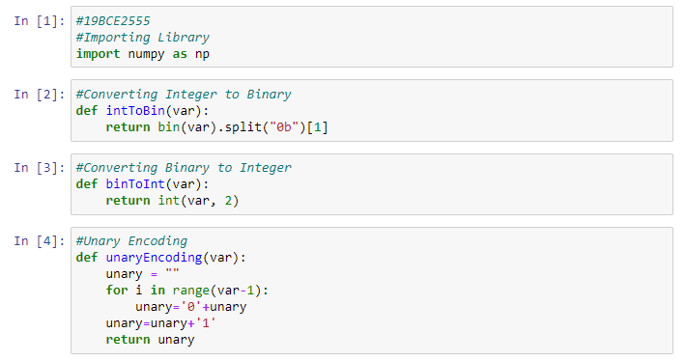 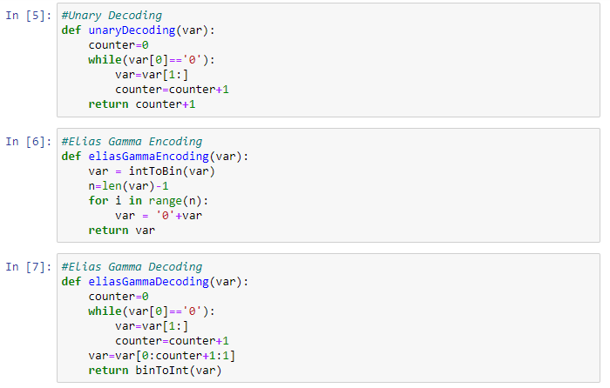 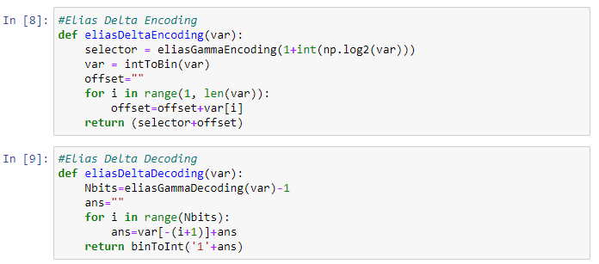 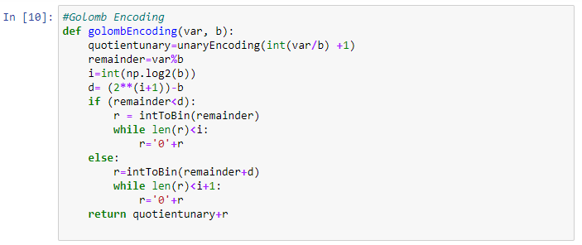 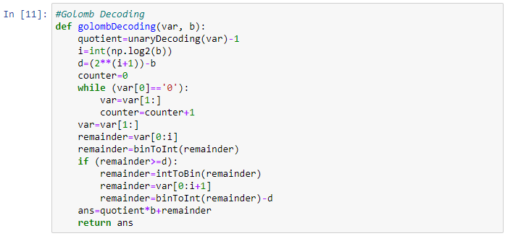

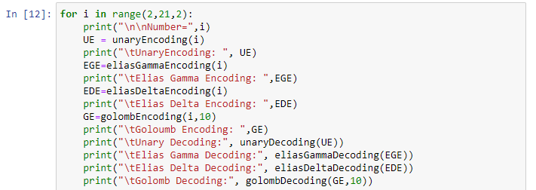

**Code Snippets and Outputs:**

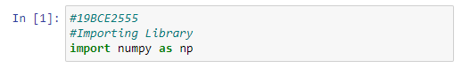

Here we are importing the libraries that are required.

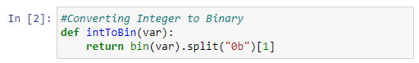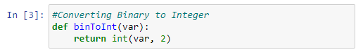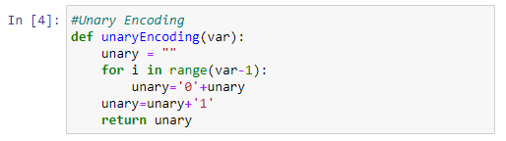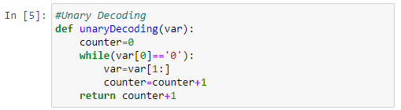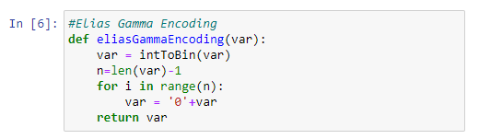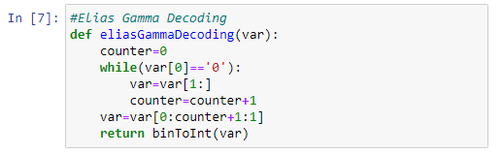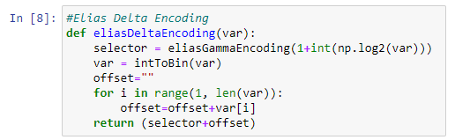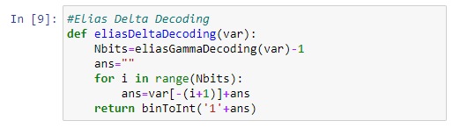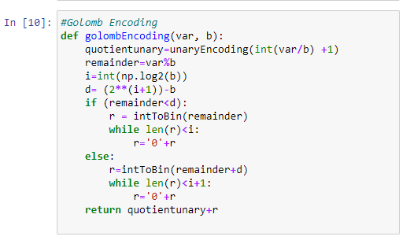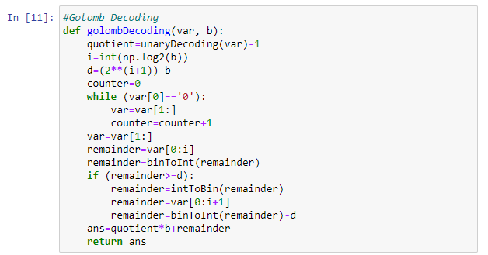

Here, we had defined all the ten functions that are described in procedure.

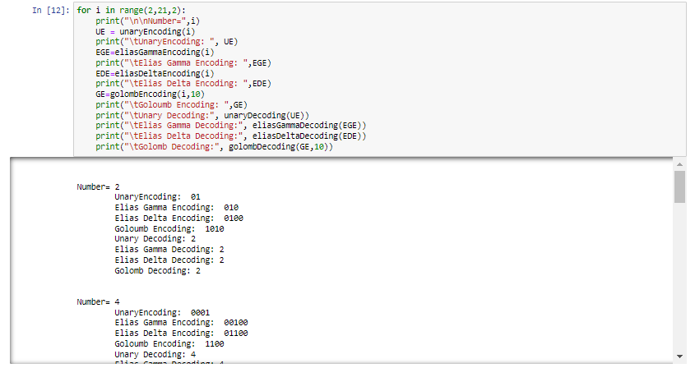

Here we are running a loop in order to iterate the even numbers in range 1-20 and then use the above functions to get our results.

**Results and Output**

